Sunday, 13 September 2026, postcard

Wine tasting at the Chateau de Rully, shopping in Beaune

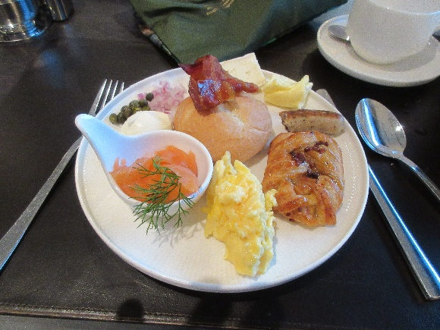
Pretty good breakfast buffet on the Lumière. In the center a crispy bread bun with bacon on top. Clockwise from the top, Brie, butter, half a sausage, a pecan pastry, scrambled egg, smoked salmon with dill, cream cheese, capers, and minced red onion. Of course, they had all the other standard stuff: cereal, cold cuts, other cheeses, fruit galore, yogurt, other breads, etc. Two odd omissions, though—no baguettes and no pains au chocolat.

Tauck passes the test of a good breakfast buffet: good scrambled eggs.

When I ordered <i>two</i> pots of hot water for tea, but no teabag, the waiter watched me pour both pots into my little traveling teapot, already equipped with my PG Tips tea bag from home, he said that next time I should just let him take the pot into the kitchen and fill it directly with hot water! Good deal.

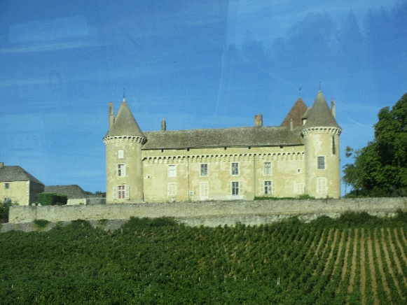
In the morning, we visited the Château de Rully, which was built by, and has been occupied by, the same family for 27 generations. The actual Count Raoul d'Aviau de Ternay. who lives there now with his family, conducted the tour, which was followed by a tasting of wines made there.

We visited several rooms that have been restored with original furniture. The walls were covered with portraits dating from the time the castle was built and coming right up to the present.

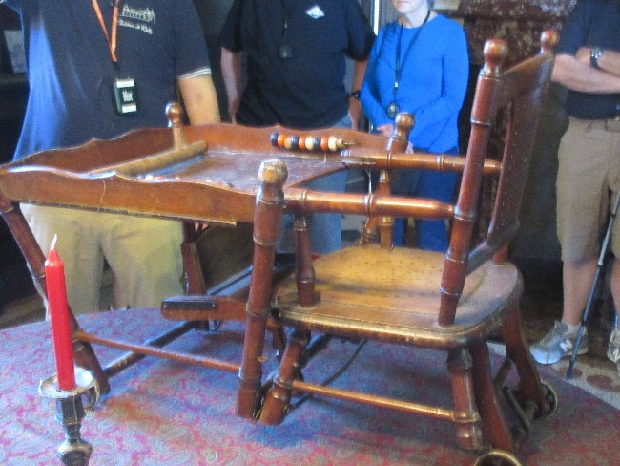
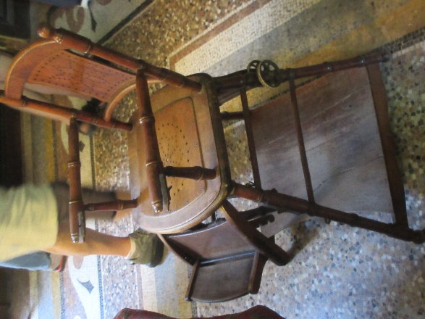
I was especially taken with this antique high chair that converted with a click and a fold into a "low chair."

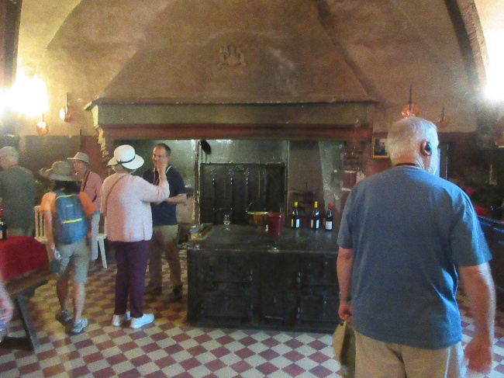
The wine tasting took place in the old kitchen. That's Rachel in the white hat chatting with the count.

The buses took us back to the ship for lunch, which consisted of an extensive salad bar and cold buffet supplemented by choices from the hot menu.

For dessert, David and Rachel both chose Oreo cheesecake, but I opted for a round slice of piña colada cake roll.

We had a choice of two afternoon excursions—a walking tour of Beaune that included a visit to the famous "hospice" (a medieval charity hospital with a world-famous colored tile roof) and a bus trip to a cooperage (barrel factory) followed by a shorter tour of Beaune without the hospice. David and I have done at least two walking tours of Beaune in the past, and he wasn't interested either in walking or in barrels, so Rachel and I set off for the cooperage. Rachel's maiden name is Cooper, and her great (or maybe great great?) grandfather was barrel-maker to the tsar of Russia, so she wanted to know all about it!

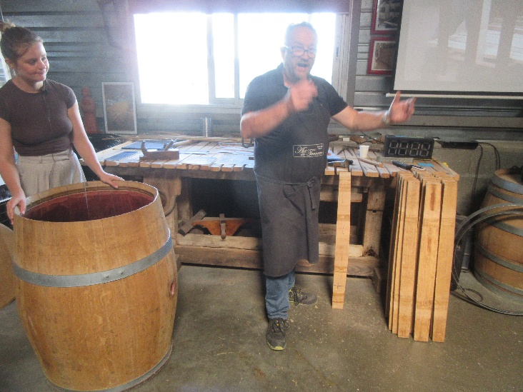
The veteran cooper didn't speak much English, so his young assistant translated for him. He started out with a fascinating lecture about how the barrel was invented by the Celts and came to replace the Roman amphora as the storage and shipping container of choice throughout the world. He told us about he relative flavor profiles and physical characteristics of French and American oak and why the latter was perfect for bourbon barrels but didn't work as well for wines. Then we got to the demonstrations and hands-on experience!

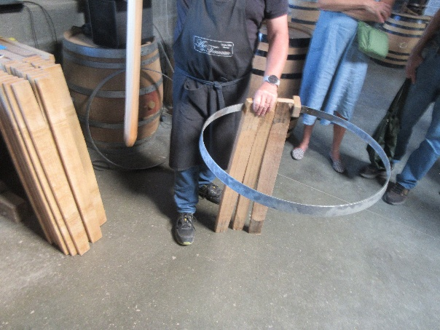
On the table in the background are laid out staves that will become a barrel. Staves inevitably vary in width, depending on the section of the trunk from which they were split (never sawn!). The secret is to select a set of staves whose widths add up to exactly the circumference of the barrel desired (about 230 cm, I think).

Then you take the smaller of two metal rings, add a "jig" (a small block with a groove that straddles the ring) and slide it up against one of the rivets holding the ends of the ring together, which it, can't slide past.

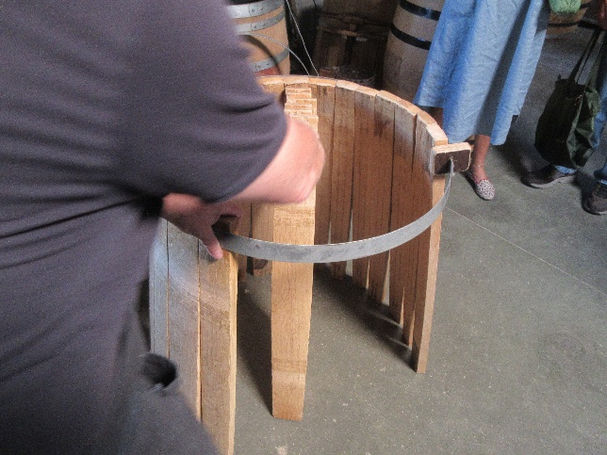
The next step is to start adding staves, pressing each one tightly against the one before and clamping it firmly to the ring with your hand, while reaching with the other for the next stave. You try to keep the ring level while working your way around the ring until the tricky bit of removing the jig and slipping that last stave into place; if you've measured accurately, it should exactly fit. Then you drop the larger of the two metal rings over the top and tamp it down hard with a blunt wedge and a heavy iron hammer. At that point, you have barrel—still splayed open at the bottom, but stably assembled and ready to shape and finish. He made it look easy.
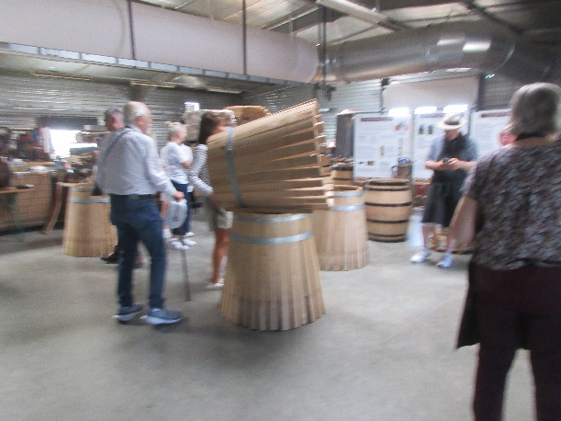
We were then issued aprons and protective gloves, divided into five teams, and presented with sets of metal rings and premeasured stacks of staves. It took three tries—our first two twisted sideways and collapsed in a heap before we got all the staves in place—but in the end, we got that second ring on and tamped into place. The cooper judged our barrel second best of the lot—it's the one forming a pedestal here and supporting the winner—and we all got our photos taken through the winning barrel.

It was a hoot and a half!

Our "tour" of Beaune turned out to be about an hour's free time to wander around the middle of town. Rachel shopped for gifts, and we sampled "pain d'épices" (usually translated gingerbread but containing no ginger). Then back into the buses for the trip back to the ship.

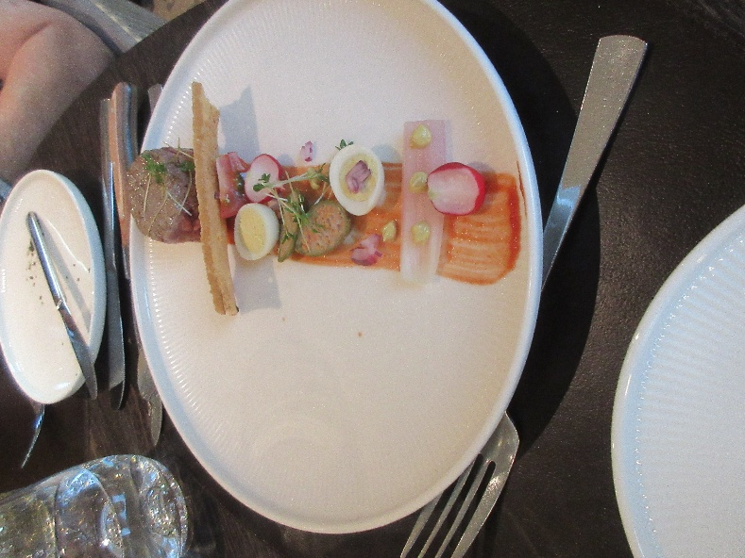
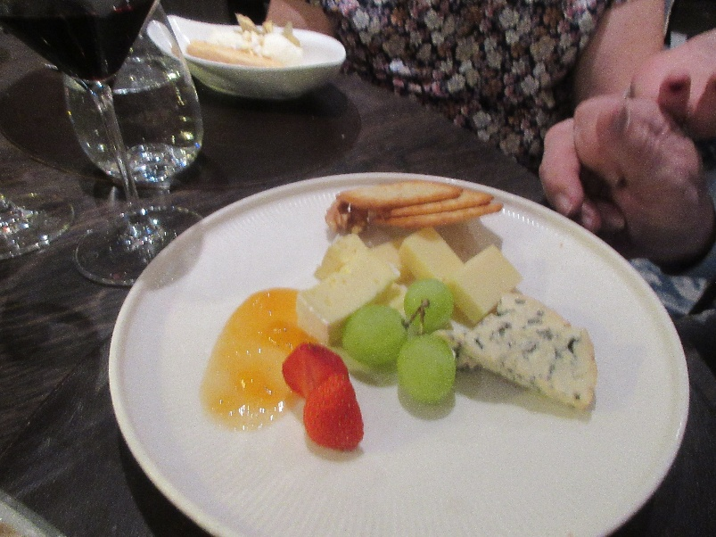
Our most photogenic dinner dishes were David's "seared beef tartare" starter and his dessert cheese plate (Bonifaz, Fourme d'Ambert, and Appenzeller)

